**GAME SET**

**RGB Electronic Target**

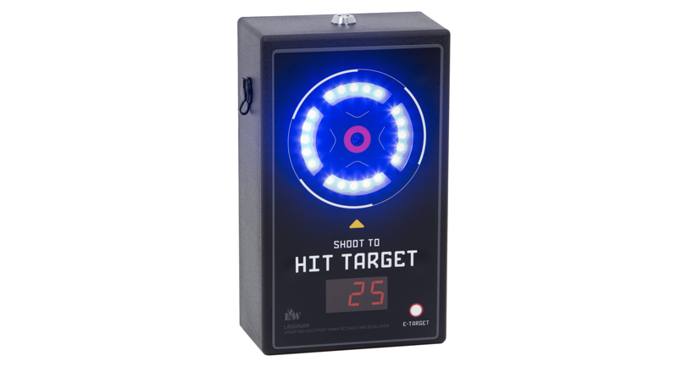

SPECIFICATION

**Smolensk**

**1. Description**

The "RGB Electronic Target" game set is an additional gaming device that can be used for laser tag equipment adjusting and testing.

**2. Field of application**

The device is designed to capture the IR beam hitting the photo sensor. It can be used in sports events events, tactical exercises, corporate and recreational activities.

**3. The set includes:**

1. Electronic target - 1 pc.
2. Product passport - 1 pc.

**4. Main technical details**

|  |  |
| --- | --- |
| Height, mm | **185** |
| Width, mm | **115** |
| Thickness, mm | **65** |
| Number of Photo sensors, pc | **1** |
| Number of RGB LEDs, pcs | **20** |
| Battery capacity, Ah | **2.2** |
| Weight, kg | **0.9** |
| Battery type | **lithium** |

**5. Device**

The game set has a black color frame made of plastic.

Inside the frame there is a battery, control junctions, mounting hardware. Inside the frame tere are 20 RGB LEDs, a sound alarm, power connector, and battery charge port.

**6. Maintenance**

All parts of the set must be treated with care if you want the equipment to function properly. There shouldn't be any mosisture inside the frame. Charge the battery on time. Recharge the set using a battery charger (the charger is not included in the set, in should be purchased purchased separately). Don't hit the device.

**7. User's manual**

The electronic target is activated by a switch located on top of the device. When activated, the display at the bottom of the battery will show the battery status.

**Changeing characteristics**

**RGB Electronic Target**

You change the settings by using the buttons on the Nano remote. You can read operating Instructions in detail on our site: laserwar.ru

**9. Guarantee obligations**

The manufacturer guarantees the reliability of the operation of an individual set if the consumer has complied with the conditions of use. Technical support is provided within **12 months** of the sale date. The manufacturer undertakes to replace or repair an individual set of equipment free of charge, if the customer has complied with the rules for the device transportation, storage, operation and delivery of defective equipment to Smolensk City.

2

3

**10. Contact information**

**Official website:**

www.laserwar.ru

**E-mail:** Purchase Date: _________________________

info@laserwar.ru

support@laserwar.ru

**Skype:**

info-laserwar.ru

support laserwar.ru



______________________________________

**Equipment Maintenance Rules**

***1. Weather conditions.*** At the course of manufacture we make different tests to see how well the equipment works under different weather conditions. Despite this, we strongly recommend that the equipment shouldn't be used in the rain and at temperatures below -20 ° C.

What should I know when using the equipment in poor weather conditions?

The most important thing is to avoid getting moisture inside the device. If this happened, turn off the device, dry the equipment at room temperature for at least two hours.

***2. Power source.*** Lithium batteries are used as a power source in this CYBERTAG game set.

It is necessary to store the equipment in a well-ventilated room at temperature from + 18°C to + 30°C and relative humidity of 45-65%.

**The warranty is 14 days for batteries, speakers, and IR modules. These components are expendable materials.**

**PLEASE NOTE! In the case of improper operation of the accumulator (charging by an unrelated type of a charger), the battery warranty is not extended!**

5

4

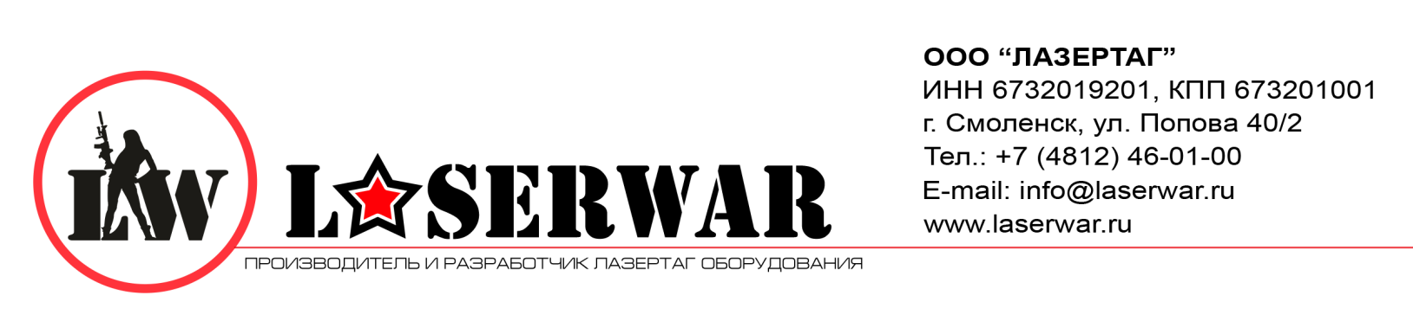

Dear Customer!

Our company welcomes and thanks you for the decision to buy our products, and is confident that the purchased device will bring you a long-term pleasure. The warranty certificate establishes the guarantee of the product in the amount provided for by the Law on consumer protection of the Russian Federation.

This warranty certificate is valid for 12 months from the purchase date of the product, and is subject to the guarantee terms.

Warranty Terms:

1. The guarantee is effective upon presentation of this coupon, which shall contain the serial number of the product and the date of its purchase, confirmed by the service centre.

These guarantee obligations apply to products acquired only from the official LASERTAG representative or the official dealer.

3. The present guarantee is invalid if the product deficiencies have occured in the following cases:

- failure to comply with Operating instructions;

- mechanical damage;

- penetration of extraneous items, liquids, etc.;

- animal activities;

Unauthorized access to the parts of the game set by non-authorized persons;

- use of the product for purposes for which it hasn't been made;

- Acts of elements (natural disaster, fire, accidents, etc.);

- the game set malfunction in case of faulty power network and/or poor care of the product.

4. If the warranty certoficate is lost, no duplicate is issued.

Information on the repairs performed during the maintenance period (completed by the Service centre performing the warranty repair works).

|  |  |
| --- | --- |
| **Data**:__________________  **Completed work:** _____________________________________________________________________  **Service centre stamp** | **Data**:__________________  **Completed work:** _____________________________________________________________________  **Service centre stamp** |
| **Data**:__________________  **Completed work:** _____________________________________________________________________  **Service centre stamp** | **Data**:__________________  **Completed work:** _____________________________________________________________________  **Service centre stamp** |
| **Data**:__________________  **Completed work:** _____________________________________________________________________  **Service centre stamp** | **Data**:__________________  **Completed work:** _____________________________________________________________________  **Service centre stamp** |

7

6